PCC Logo**PASADENA AREA COMMUNITY COLLEGE DISTRICT**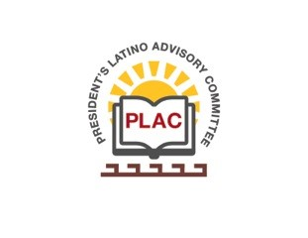

**President’s Latino Advisory Committee (PLAC)**

**Mission:** *To enhance the success of Latino students at PCC*

**Wednesday, July 17, 2019, 10:00 AM**

Pasadena City College

President’s Conference Room

1570 East Colorado Boulevard, Pasadena, CA 91106

1. Welcome and Introductions
2. Approval of Minutes: June 19, 2019
3. President’s Report (Erika Endrijonas)
4. Reports
   1. ALE Update (Tito Altamirano)
   2. LatinX (Hispanic) Heritage Month (Tito Altamirano)

September 15th to October 15th

1. New Business
2. Around the Table
3. Announcements
4. Adjourn