PCC Logo**PASADENA AREA COMMUNITY COLLEGE DISTRICT**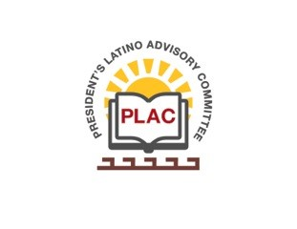

**President’s Latino Advisory Committee (PLAC)**

**Mission:** *To enhance the success of Latino students at PCC*

**Wednesday, August 20, 2019, 10:00 AM**

Pasadena City College

President’s Conference Room

1570 East Colorado Boulevard, Pasadena, CA 91106

1. Welcome and Introductions
2. Approval of Minutes: July 17, 2019
3. President’s Report (Erika Endrijonas)
4. Reports (Carlos ‘Tito’ Altamirano)
5. Bienvenido Day
6. Latinx Heritage Month (9/15-10/15)
7. Latino Heritage Parade
8. Adelante Young Men Conference
9. New Business
10. Around the Table
11. Announcements
12. Adjourn