PCC Logo**PASADENA AREA COMMUNITY COLLEGE DISTRICT**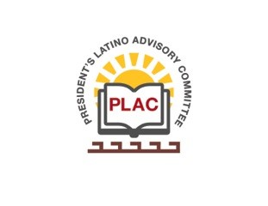

**President’s Latino Advisory Committee (PLAC)**

**Mission:** *To enhance the success of Latino students at PCC*

**Wednesday, December 18, 2019**

**10:00 AM – 11:30AM**

Pasadena City College

President’s Conference Room

1570 East Colorado Boulevard, Pasadena, CA 91106

1. Welcome and Introductions
2. Approval of Minutes: October 16, 2019 & November 20, 2019
3. President’s Report (Erika Endrijonas)
4. Reports
5. New Business
6. Around the Table
7. Announcements
8. Adjourn