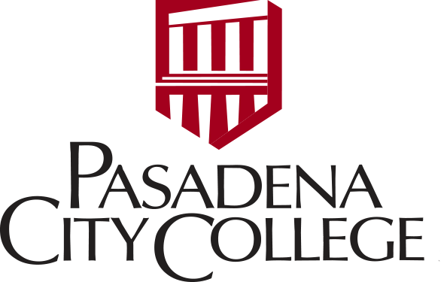
PCC PAAPI Advisory Committee
March 9, 2019

ACTION MINUTES

Attendees: B Takeda, C Wei, S Ryan, H Dao, J Shamim, O Loo, J Chang, L Wah, C Liu, J Chen, D Mitoma, V Chan, K Kouanchou, T Thongthiraj, V Chan

Absent: S Shamim, P Wong, G Yuen, A Yee, S Chou, H Lo, R Sakata, M Freridge

- Minutes 9/27/18 Approved: Moved L Wah; 2nd T Thongthiraj

- President Endrijonas Welcome – No Report

- Community Input: Deeper dive in data to look at issues of our various communities and differences (data disaggregation) and effect/outcomes for our students and programs that are needed to address needs

- AANAPISI (Tooktook) - CAPE – will work with Crystal, grant writing staff and try to identify an external evaluator to move forward on process. Dr Endrijonas gave some feedback on steps that can be taken. Tooktook and CAPE will take the lead to move the application forward.

- API Symposium (Tooktook)

- Symposium was a success; Stats on attendance and feedback will be further analyzed with Outreach Center (T Alexander)
- Improve notification of event to PAAPI members Not all PAAPI members were notified and we need to review the Distribution List
- Need to increase survey/feedback
- Debriefing meeting will be held to identify further improvements, including access to translators, programming, and measured outcomes for event

- 2 new PAAPI Members were approved: Cynthia Liu and Irene Lee. Office should add to the list of members and distribution list

- International Student Oppty – Cathy Wei presented a Cerritos CCD international program as an example and will work with new O Loo on possible future proposal

- International Students Program - Olivia Loo is new Director – Program will focus on more outreach and addressing issues that International Student face.

- Linda requested PCC review the process of accepting International HS student

- New Business:

- Dr Endrijonas asked to review procedure for parking permits and distribution list for meetings and notes

Announcements (Links to the following programs announced will be sent in later email)
- 5/6-10 - International Day - Send Calendar link (Cathy)
- APAHM- 5/25,26 – Mission/San Gabriel celebration - send link (Vivian)
- DSPS Family Night (flyer- Ket)
- Huntington Medical Research Inst (Joseph)
- San Marino Reception for Dr Endrijonas (4/22) – Invite will be sent to PAAPI members
- Discussion on 4/5 - Recapping info on LAUSD Strike and legislation (Cynthia)
- Report rec’d from Wang Foundation Scholarship (Sallie via Shelley R)

Next Meeting Dates: 6/8 9/14 2/14

11:15am Adjournment

