PCC Logo**PASADENA AREA COMMUNITY COLLEGE DISTRICT**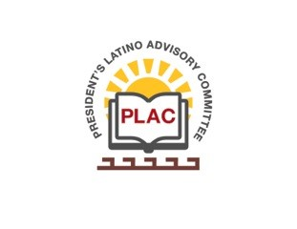

**President’s Latino Advisory Committee (PLAC)**

**Mission:** *To enhance the success of Latino students at PCC*

**Wednesday, January 20, 2021**

**10:00 AM – 11:30AM**

Pasadena City College

Zoom Meeting

1. Welcome and Introductions
2. Approval of Minutes- December 16, 2020
3. President’s Report (Erika Endrijonas)
4. Reports
5. Announcements
6. Adjourn