PCC Logo**PASADENA AREA COMMUNITY COLLEGE DISTRICT**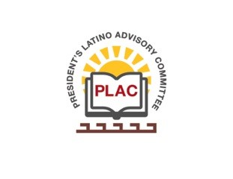

**President’s Latino Advisory Committee (PLAC)**

**Mission:** *To enhance the success of Latino students at PCC*

**Wednesday, July 15, 2020**

**10:00 AM – 11:30AM**

Pasadena City College

Zoom Meeting

1. Welcome and Introductions
2. Approval of Minutes- June 17, 2020
3. President’s Report (Erika Endrijonas)
4. Hiring Diverse Faculty/Administrators (Aragon)
5. Faculty/Admin Internship Programs (Aragon)
6. Reports
7. Announcements
8. Adjourn