PCC Logo**PASADENA AREA COMMUNITY COLLEGE DISTRICT**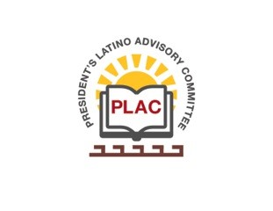

**President’s Latino Advisory Committee (PLAC)**

**Mission:** *To enhance the success of Latino students at PCC*

**Wednesday, September 15, 2021**

**10:00 AM – 11:30AM**

Pasadena City College

Zoom Meeting

1. Welcome
2. Approval of Minutes (August 18, 2021)
3. President’s Report (Erika Endrijonas)
4. Latinx/a/o Heritage Month (Zuniga and Vasquez)
5. Reports & Announcements
6. Adjourn