PCC Logo **PASADENA AREA COMMUNITY COLLEGE DISTRICT**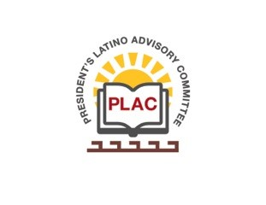

**President’s Latino Advisory Committee (PLAC)**

**Mission:** *To enhance the success of Latino students at PCC*

**Wednesday, December 13, 2017 10:00 AM**

Pasadena City College

President’s Conference Room

1570 East Colorado Boulevard, Pasadena, CA 91106

1. Welcome and Introductions
2. Approval of Minutes
3. President’s Report (Rajen Vurdien)
4. Reports
   1. EEO Plan
5. Scholarship Update
6. Set next quarterly meeting date
7. Around the table
8. New Business
   1. Mission Statement Review – Crystal Kollross
9. Announcements
10. Adjourn