PCC Logo **PASADENA AREA COMMUNITY COLLEGE DISTRICT**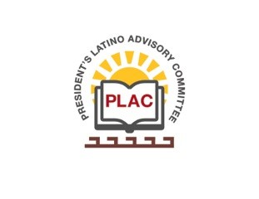

**President’s Latino Advisory Committee (PLAC)**

**Mission:** *To enhance the success of Latino students at PCC*

**Wednesday, June 13, 2018 10:00 AM**

Pasadena City College

President’s Conference Room

1570 East Colorado Boulevard, Pasadena, CA 91106

1. Welcome and Introductions
2. Approval of Minutes: March 14, 2018
3. President’s Report (Rajen Vurdien)
4. Reports
5. Scholarship Dinner Update
6. Puente
7. Equity Dashboard
8. Meeting Schedule:
   1. September 12, 2018
   2. December 12, 2018
9. Around the table
10. New Business
    1. PCC Image | High School Students – Ana Chavez
11. Announcements
12. Adjourn