PCC Logo**PASADENA AREA COMMUNITY COLLEGE DISTRICT**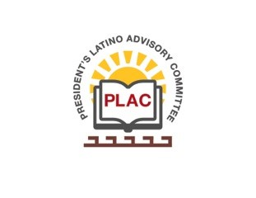

**President’s Latino Advisory Committee (PLAC)**

**Mission:** *To enhance the success of Latino students at PCC*

**Wednesday, February 20, 2019, 2018 10:00 AM**

Pasadena City College

President’s Conference Room

1570 East Colorado Boulevard, Pasadena, CA 91106

1. Welcome and Introductions
2. Approval of Minutes: No minutes
3. President’s Report (Erika Endrijonas)
4. Reports

**Tito**

* 1. PLAC Scholarship Dinner
  2. Latinx Grad
  3. Association of Latino Employees update
  4. Hiring Latin@ professionals at PCC

1. Meeting Schedule:

March 20 August 21

April 17 September 18

May 15 October 16

June 19 November 20

July 17 December 18

1. New Business
   1. Latino/Chicano Heritage Room and Upcoming Exhibitions
2. Around the Table
3. Announcements
4. Adjourn

**Next Meeting Date: Wednesday, March 20th, 2019**