PCC Logo**PASADENA AREA COMMUNITY COLLEGE DISTRICT**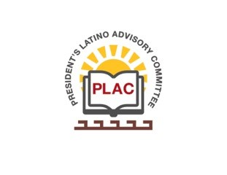

**President’s Latino Advisory Committee (PLAC)**

**Mission:** *To enhance the success of Latino students at PCC*

**Wednesday, April 17, 2019, 2018 10:00 AM**

**Start time: 10:15am**

1. Welcome and Introductions around the table
2. Approval of Minutes: March 20th, 2019
   1. Approved with some changes to the grant for formerly incarcerated students. The number originally stated has changed to a lesser amount and Michaela will inform us of the amount when notified.
   2. Ana Chavez spoke about the Ayudame program being connected through PCC as a work study program and/or service learning hours.
   3. Based off of these changes the minutes have been approved.
3. President’s Report (Erika Endrijonas)
   1. PLAC & ALE had a wonderful reception for the President at the Rosemead campus.
   2. The President attended the D.C Aspen prize where wonderful things were said about the college and feedback will be given on the application in the coming weeks. It is to be noted that we pay a great amount of attention to our full time students and one area of focus for next time is the focus on part-time students.
   3. We are in the process of finding our new CBO. Position has been reopened and interviews will be taking place within a week or so.
   4. HR is actively working on the listings of Latino hiring in the last 10-15 years and the list should be available for the next PLAC meeting.
4. Reports
   1. Crystal joined us in PLAC to give a presentation on Vision for Success and the Local Goal setting.
5. New Business
   1. PLAC Scholarship dinner will be on Tuesday May 21st from 6:30pm-8:30pm.
   2. Dodger Game will be on May 7th at 7:10pm tickets sold at the student bank
   3. Flyer for a Town Hall event taking place in the Creveling Lounge called #PCCTHRIVE. It will take place on April 25th from 5:00pm-7:30pm
   4. A pamphlet handed out with a calendar of events called Gala for La Plaza.
6. **Adjourn: 11:31am**